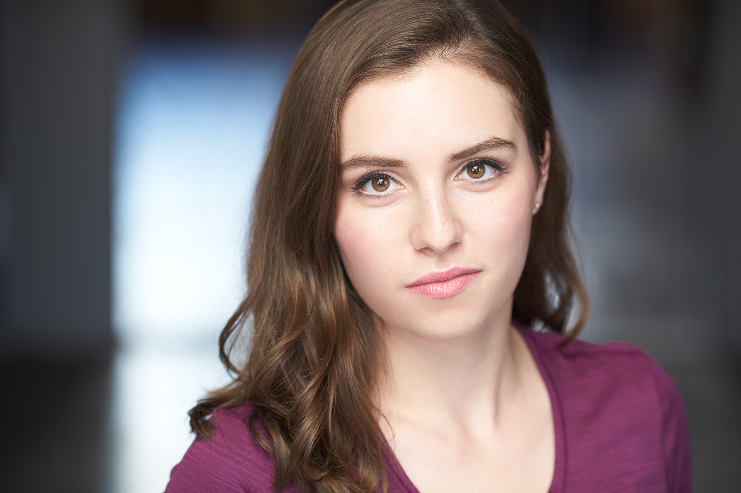
Victoria Newhuis
EMC
www.victorianewhuis.com
victoria.newhuis@gmail.com
(630) 877-7276
E♭3 – E6 Soprano/Mix/Belt
Height: 5’4” | Hair: Brown | Eyes: Brown

TOUR

Rodgers+Hammerstein’s ’18-’19 DC, Swing, u/s Ella Work Light Productions/dir. Gina Rattan
Cinderella (2nd National) ’17-’18 Temp. Ella Replacement, chor. Lee Wilkins Swing, ADC

REGIONAL

42nd Street* Ethel, us Dorothy Reagle Music Theatre/dir. Eileen Grace
Show Boat Dottie Reagle Music Theatre/dir. Rachel Bertone
Picnic at Hanging Rock** Marion Quade Goodspeed Opera House/dir. Tyne Rafaeli
West Side Story Francisca Opera North/dir. Evan Pappas
A Chorus Line Bebe Priscilla Beach Theatre/dir. Emily Maltby
A Little Night Music Petra NextDoor Theatre Company
A Midsummer Night’s Dream Starveling/Mustardseed Citadel Theatre Company

*denotes original Broadway choreography
**denotes Staged Reading

OTHER

Places, Please! Cabaret Guest Artist SpeakEasy Stage Company/dir. Larry Sousa
Hosted by Nicky Silver
World Of Color Winter Dreams Featured Vocalist – “Glow” Disneyland, California
by Eric Whitacre
TRAINING

Education: The Boston Conservatory ‘17 - BFA in Musical Theatre Performance with Dance Emphasis
Voice: Lisa Saunderson
Dance: Ballet, Jazz, Tap (Rhythm and Musical Theatre), Pointe, Modern, Partnering
Speech: Linklater, Lessac, heightened language
Acting: Grotowski, Meisner, Suzuki, Viewpoints, Classical

SKILLS

Painting Instructor, a cappella choral arranger, harnessed flight, strong harmonization skills/tonal memory, can move eyes independently, video/movie editing.

Dialects: British RP, Cockney, Estuary, Irish, Mid-Atlantic, Southern American, French, German, Russian. Can pick up new dialects quickly.

